CASH CROP LOSS PREDICTION

A PROJECT REPORT

Submitted by,

Ms.Rishitha chinmayi - 20201CSD0053 Mr. Reddy kiran -20201CSD0016
Mr. Harsha vardhan -20201CSD0038 Mr. Jaswanth -20201CSD0012

Mr. Teja vamsi -20201CSD0047

Under the guidance of,

Dr.HarishKumar K S

in partial fulfillment for the award of the degree of

BACHELOR OF TECHNOLOGY

IN

COMPUTER SCIENCE AND ENGINEERING
(DATA SCIENCE)

At



PRESIDENCY UNIVERSITY BENGALURU JANUARY 2024

SCHOOL OF COMPUTER SCIENCE ENGINEERING & INFORMATION SCIENCE

CERTIFICATE

This is to certify that the Project report “CASH CROP LOSS PREDICTION” being submitted by “Ms.Rishitha Chinmayi, Mr. Reddy Kiran, Mr. Harsha Vardhan, Mr. Jaswanth, Mr. Teja vamsi ” bearing roll number(s) “20201CSD0053, 20201CSD0016, 20201CSD0038, 20201CSD0012, 20201CSD0047”in partial fulfillment of requirement for the award of degree of Bachelor of Technology in Computer Science and Engineering is a bonafide work carried out under my supervision.

Dr Harish kumar K S  Asst.Professor School of CSE&IS  Presidency University | Dr. Jayachandran  Professor & HOD  School of CSE&IS Presidency University

Dr. C. KALAIARASAN  Associate Dean School of CSE&IS  Presidency University | Dr. L. SHAKKEERA  Associate Dean School of CSE&IS  Presidency University | Dr.MD.SAMEERUDDIN KHAN Dean  School of CSE&IS  Presidency University

SCHOOL OF COMPUTER SCIENCE ENGINEERING & INFORMATION SCIENCE

DECLARATION

We hereby declare that the work, which is being presented in the project report entitled CASH CROP LOSS PREDICTION in partial fulfillment for the award of Degree of Bachelor of Technology in Computer Science and Engineering, is a record of our own investigations carried under the guidance of Dr. HarishKumar K S, Asst. Professor, School of Computer Science Engineering & Information Science, Presidency University, Bengaluru.

We have not submitted the matter presented in this report anywhere for the award of any other Degree.

Ms.Rishitha chinmayi Mr. Reddy kiran  Mr. Harsha vardhan Mr. Jaswanth  Mr. Teja vamsi | 20201CSD0053  20201CSD0016  20201CSD0038  20201CSD0012  20201CSD0047

In general, agriculture is the backbone of India and also plays an important role in Indian economy by providing a certain percentage of domestic product to ensure the food security. In India agriculture contributes approximately 23% of GDP and employed workforce percentage is 59%. India is the second-largest producer of agriculture crops. the technological contribution may help the farmer to get more yield. But now-a-days, food production and prediction is getting depleted due to unnatural climatic changes, which will adversely affect the economy of farmers by getting a poor yield and also help the farmers to remain less familiar in forecasting the future crops. This research work helps the beginner farmer in such a way to guide them for sowing the reasonable crops by deploying machine learning, one of the advanced technologies in crop prediction. The main aim of machine learning is to instruct computers to use data or experience to solve a real-life problem. In this study, we will focus on the use of machine learning in agriculture to solve real-life problems.
So we proposed a system with the help of machine learning techniques and algorithms like Linear Regression and Random Forests Regress-or to predict the crop can be grown based on different parameters entered by the user in the front end like state and district name, temperature, humidity, moisture content and pH value. Here Random Forest Regress er gave 100% accuracy and it is used as final model for crop prediction.

First of all, we indebted to the GOD ALMIGHTY for giving me an opportunity to excel in our efforts to complete this project on time.
We express our sincere thanks to our respected dean Dr. Md. Sameeruddin Khan, Dean, School of Computer Science Engineering & Information Science, Presidency University for getting us permission to undergo the project.
We record our heartfelt gratitude to our beloved Associate Deans Dr. Kalaiarasan C and Dr. Shakkeera L, School of Computer Science Engineering & Information Science, Presidency University and “Dr. A Jayachandran”, Head of the Department, School of Computer Science Engineering & Information Science, Presidency University for rendering timely help for the successful completion of this project.
We are greatly indebted to our guide Dr.Harish kumar K S, Asst.Professor, School of Computer Science Engineering & Information Science, Presidency University for his inspirational guidance, and valuable suggestions and for providing us a chance to express our technical capabilities in every respect for the completion of the project work. We would like to convey our gratitude and heartfelt thanks to the University Project-II Coordinators Dr. Sanjeev P Kaulgud, Dr. Mrutyunjaya MS and also the department Project Coordinators Dr Manjula and Mr.Yamannapa.
We thank our family and friends for the strong support and inspiration they have provided us in bringing out this project.

Ms.Rishitha chinmayi Mr. Reddy kiran
Mr. Harsha vardhan Mr. Teja vamsi

Mr. Jaswanth

LIST OF FIGURES

Sl. No. | Figure Name | Caption | Page No.
1 | Figure 6.1 | System Design: System Architecture | 15
2 | Figure 6.2 | Data Flow Diagram | 17
3 | Figure 6.3 | Use Case Diagram | 19
4 | Figure 6.4 | Activity Diagram | 21
5 | Figure 6.5 | Sequence Diagram | 23
6 | Figure 6.6 | Class Diagram | 25
7 | Figure 6.7 | Flow Chart | 26

TABLE OF CONTENTS

CHAPTER NO. | TITLE | PAGE NO.
 | ABSTRACT ACKNOWLEDGMENT  LIST OF FIGUERS | i ii  6
1. | INTRODUCTION | 8
 | 1.1 Intro on Cash Crop Data Set | 8
 | 1.2 Summary | 8
 | 1.3 Completion | 8
2. | LITERATURE REVIEW | 9-12
3. | Research Gaps and Existing Methods | 13-14
4. | Proposed Methodology | 15-16
5. | Objectives | 17-18
6. | System design and Implementation | 19
 | Figure 6.1 System Architecture | 20
 | Figure 6.2 Data flow Diagram | 21
 | Figure 6.3 Use Case Diagram | 23
 | Figure 6.4 Activity Diagram | 25
 | Figure 6.5 Sequence Diagram | 27
 | Figure 6.6 Class Diagram | 29
 | Figure 6.7 Flow chart | 30
7. | Timeline for Execution of Project | 31
8. | Outcomes | 32
9. | Results and Discussion | 33
10. | Conclusion | 34
 | References | 35 -36
 | Appendix A | 37-38
 | Appendix B | 39 - 40
 | Appendix C | 41

CHAPTER-1 INTRODUCTION
  - Introduction
    - Intro on Cash Crop Data Set
Since ancient times, agriculture has been considered the basic daily food source of people. It is also considered as a big business and one of the largest industries in India. Farmers must follow blind inspections and grow healthy crops without using pesticides and without tillage to ensure healthy diversity. But today the climate is changing rapidly, affecting essential crops, causing food shortages and increasing security. At the same time, the GDP of agriculture continued to decline, reaching approximately , 11.1 percent in 2012, 5 percent in 2018, and 2 percent in the first three months of 2020-2020. fell to . Approximately 80% of farmers come from rural areas and their livelihoods will be affected by agriculture if income from crops decreases..
  - Summary :
Since ancient times, agriculture has been considered an important source of food for people's daily lives. It is also a large business and is considered to be one of the largest businesses in India. To ensure a healthy variety, farmers must follow blind control and grow healthy crops without the use of pesticides or tillage. However, today the climate is changing rapidly, affecting important resources, causing food insecurity and increasing insecurity. At the same time, agricultural GDP continued to decline, reaching 17.2% in 2005, 11.1% in 2012, 5% in 2018 and 2% in the first three months of 2020-2020. Autumn. Approximately 80% of farmers come from rural areas and their health will be affected by agriculture if crop yields decrease.

  - Completion :
There may be a logical classifier that predicts the likelihood of membership in each group, such as the likelihood of knowledge belonging to a particular class, as naive mathematicians do. Accordingly, we proposed a system that predicts the feasibility of crop production based on various parameters such as name, temperature, and humidity entered by the user on the front end by utilizing machine learning techniques and algorithms such as linear regression analysis and random forest regression analysis. did. etc d. Moisture content and pH value. Here Random Forest Regresser provides 100% accuracy and is used as the final model for yield prediction.

CHAPTER-2 LITERATURE SURVEY
- Kalimuthu ,P.Vyshnavi: Proposed Supervised Machine Learning Using Naive Bayes Gaussian Classifier with Boosting Algorithm Designed for High Accuracy Yield Prediction. Therefore, the seed is predicted as the result for given input parameters. This work could go a long way in creating a sustainable future for struggling farmers who lack knowledge about crop forecasting. In the future, it may be expanded to provide suitable fertilizer for arable land and crops for given resources..
2.Medar, V. S. Rajpurohit and S. Shweta : The model will able to predict better in the real-time dataset which will be a more effective suggestion to the farmer for making crop choice. Using ANN with linear regression with forward and backward propagation the model predicted the dependent variable with 82 % accuracy and very little loss. The proposed model with backpropagation is trying to reduce MSE by using RELU activation function and gradient decesent.

3. Nigam, S. Garg, A. Agrawal and P. Agrawal : The paper presented the various machine learning algorithms for predicting the yield of the crop on the basis of temperature, rainfall, season and area. Experiments were conducted on Indian government dataset and it has been established that Random Forest Regressor gives the highest yield prediction accuracy. Sequential model that is Simple Recurrent Neural Network performs better on rainfall prediction while LSTM is good for temperature prediction.

4.Rahman, K. Chandra and S. M. Mohidul Islam : A model is proposed for predicting soil series and providing suitable crop yield suggestion for that specific soil. The research has been done on soil datasets of Khulna region. The model has been tested by applying different kinds of machine learning algorithm.

5.Elavarasan and Vincent : The proposed method can precisely define the characteristics for crop yield. The combination of RNN based feature processing and DQN based self experimental analysis is the key objective to attain favorable results. Unlike the supervised learning-based crop yield prediction process, DRQN based process provides a complete solution that independently mines the non-linear mapping between the crop yield and the climatic, soil and groundwater parameters. This advantage can definitely minimize expert dependency and prior knowledge for developing crop yield prediction models. Hence the proposed approach provides a perception of implementing a more generalized model for yield prediction.
6..Nishant, Sai Venkat, Avinash and Jabber: Mean square error was used in this project. When the models were applied individually, it was about 4% for ENet, about 2% for Lasso, about 1% for Kernel Ridge, and about less than 1% after stacking. Users or farmers can obtain forecasts by inputting the following data through the web application
7 S. S. Kale and P. S. Patil: The model will be able to make better predictions on real-time data, which will provide farmers with recommendations on crop selection. Forward and Backward Linear Regression Using ANNThe presented model predicts the variance with 82% accuracy and a slight decrease. The model also suggests crop yield based on farmer inputs. The model therefore shows the best crops with the best possible results.
4.Z. Doshi, S. Nadkarni, R. Agrawal and N. Shah: In this paper, they developed and implemented crop recommendations that can be easily implemented by farmers across India. The system will help farmers make informed decisions about which crops to grow based on various environmental and geographical conditions. The models presented in this paper can be extended to include the ability to predict crop rotation in the future. This will ensure that the largest crop determined by the current crop is also based on what was recorded .

CHAPTER-3
RESEARCH GAPS OF EXISTING METHODS

3.1 Multi-Scale Modeling:
Investigate the development of multi-scale models that can effectively capture variations in cash crop losses at different spatial and temporal scales. Current models may lack granularity in addressing localized variations and seasonal changes.

3.2 Integrated Pest and Disease Models:
Explore the integration of pest and disease modeling with crop loss prediction. Existing models often focus on climatic factors, but incorporating biological aspects could provide a more comprehensive understanding of the factors contributing to crop losses.

3.3 Incorporation of Geo-spatial Data:
Assess the potential of integrating advanced Geo-spatial data, such as high-resolution satellite imagery and drone data, into crop loss prediction models. These data sources can enhance the accuracy and precision of predictions by providing detailed information about crop health and environmental conditions.

3.4 Crop-Specific Models:
Develop crop-specific models that consider the unique characteristics and vulnerabilities of different cash crops. Generic models may not capture the intricacies of individual crops, limiting their accuracy in predicting losses.

3.5 Dynamic Adaptive Models:
Explore the development of dynamic adaptive models that can continuously learn and adjust based on real-time data. This is particularly important in the context of changing climate patterns and evolving agricultural practices.

3.6 Uncertainty Quantification:
Investigate methods for quantifying and communicating uncertainties in crop loss predictions. Understanding the limitations and confidence levels of predictions is crucial for effective decision- making by farmers and policymakers.
Impact of Climate Extremes:

Assess the impact of extreme climate events, such as heatwaves, floods, and droughts, on cash crop losses. Existing models may not adequately account for the severity and frequency of such events.

CHAPTER-4 PROPOSED METHODOLOGY
- Agriculture data set is taken.

- The data set is loaded and pre processed with various machine learning techniques.

- The pre processed data is divided as training and testing data.

- The prediction model is built using machine learning algorithms Linear Regression and Random Forest Regress or.

- The model is trained using training data set and once the model has been trained successfully it has to be tested.

- The trained model is tested using testing data set and accuracy is calculated.

- The algorithm which gives the best accuracy is taken as our final prediction model.

- The finalized model is converted into pickle model (binary format data) and saved.

- A Front End is developed with the help of Flask and HTML.

- Now user will enter the state name, district name, temperature, humidity, pH, moisture content in the front end.

- The collected data from the user is given as input to our finalized algorithm to predict the crop can be grown.

- Finally the predicted Crop output is displayed on the front end and also suggested fertilizers should be used based on pH value entered by the user in the front end.

CHAPTER-5 OBJECTIVES
The main aim of this project to predict the crop can be grown based on different data like temperature, humidity, pH and moisture content with good accuracy with help of machine learning techniques and algorithms.

5.1 Data Collection and Integration:
Gather historical and real-time data on relevant factors affecting crop health, such as weather conditions, pest and disease prevalence, soil quality, and farming practices.
Integrate diverse datasets, including satellite imagery, meteorological data, and ground-based observations, to provide a comprehensive input for prediction models.

5.2 Model Development:
Design and implement robust prediction models that leverage machine learning, statistical analysis, or other advanced techniques to forecast potential cash crop losses.
Explore the development of crop-specific models that account for the unique characteristics and vulnerabilities of different crops.

5.3 Feature Engineering and Selection:
Identify key features and variables influencing crop losses through thorough analysis and domain expertise.
Implement feature engineering techniques to enhance the predictive power of the models, and optimize the selection of relevant features.

5.4 Dynamic Modeling:
Develop models that are dynamic and adaptive, capable of adjusting to changing environmental conditions and evolving agricultural practices.
Implement mechanisms for continuous learning to improve the accuracy of predictions over time.

5.5 Validation and Bench marking:
Conduct rigorous validation studies to assess the performance of the developed models using diverse datasets and under various environmental conditions.
Establish bench marking protocols to compare the proposed models against existing methods, ensuring transparency and reliability.

Model Evaluation

Test the model

CHAPTER-6
SYSTEM DESIGN & IMPLEMENTATION

Agriculture Dataset
Train Data
Test Data

Train the model

Compring accuracy

 |  | Final Model
User input from frontend |  | Final Model

Output
  - Flowchart of System Architecture

  - Agriculture data set is taken and loaded.
  - The data is pre processed to clean the data and understand the data set.
  - The data is split as training and testing data.
  - The model is built using machine learning algorithms like Linear Regression and Random Forest Regress or.
  - The model is trained with the pre processed data.
  - The model is tested and accuracy is calculated for different ML algorithms.
  - The algorithm with best accuracy is finalized and that model will predict the crop can be grown and also suggest which fertilizers should be used based on user given new data from front end.

Data Flow Diagram
Load Data
Agriculture Dataset

Pre-process Data
Predict

Final Model
Results

Train Model
Best Fit algorithm
Linear Regression and Random Forest
Regressor
Test Model
Find Accurate Algorithm

Performance Evaluation

User Input

Front End

  - Data Flow Diagram

  - Agriculture data set is taken and loaded.
  - The data is pre processed in order to fill the missing values and converting strings to numeric data etc. in the data set etc to increase the accuracy.
  - The model is built using machine learning algorithms like Linear Regression and Random Forest Regress or.
  - The model is trained with the pre processed data.
  - The model is tested and accuracy is calculated for different ML algorithms.
  - The algorithm with best accuracy is finalized and that model will predict the crop can be grown and also suggest which fertilizers should be used based on user given new data from front end.

Use Case Diagram

Input (Dataset)

Train Data

Test Data

Save Module

User

Load Module

Predict

Output (Crop Prediction)

System

  - Use Case Diagram

  - The system will collect the data from the user.
  - The system will analyze the collected data .
  - The system will do preprocessing and model building.
  - The built model is evaluated and tested for accuracy.
  - The user will finalize the model with best accuracy.
  - The user will give new data to the system and the model will predict results and display .

Activity Diagram

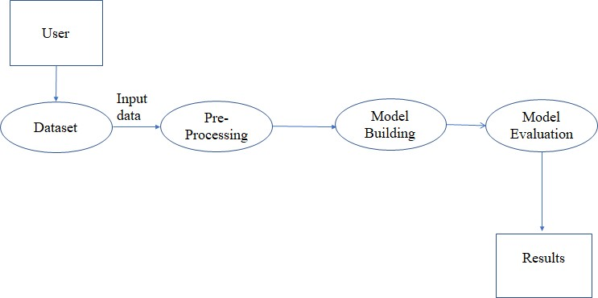

  - Activity Diagram

  - The user will provide the data set to the system.
  - The data set is pre processed in order to increase the accuracy of the model.
  - The model is built using different algorithms.
  - The model is evaluated and model with best accuracy is finalized.
  - The finalized model will predict the results.

Sequence Diagram

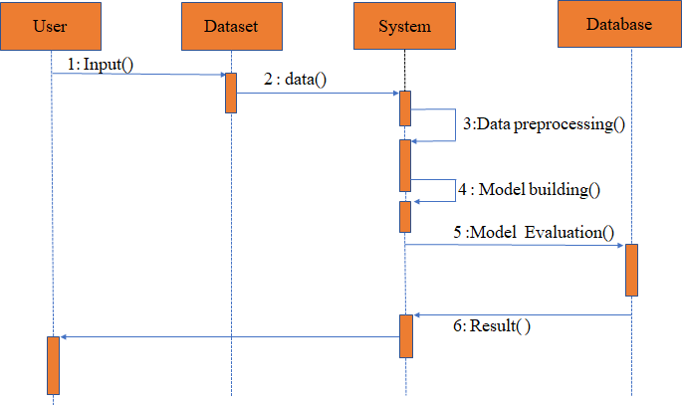

  - Sequence Diagram

  - The user will give dataset as input to the system.
  - The system will store the dataset given by the user in its database.
  - The system will do preprocessing of the data stored.
  - The model is built using various ML algorithms and trained using preprocessed data.
  - The model is evaluated and the algorithm with best accuracy is finalized.
  - The finalized model will predict the results.

Class Diagram

Data Preprocessing Techniques

Agriculture Dataset

User Input from Front End

Data Splitter

Machine Learning Algorithm

Result

  - Class Diagram

Flow Chart:

Start

Load the agriculture Dataset

Data Preprocessing

Splitting the Dataset
Training the Different ML Algorithms
Finalizing the algorithm with highest accuracy

New User Input Data From Front End

Finalized Algorithm

Stop

Predicted Output

  - Flow Chart

CHAPTER-7
TIMELINE FOR EXECUTION OF PROJECT (GANTT CHART)

S. No. | Review(Offline) | Dates
1 | Review-0 | 09-Oct-2023 to 13-Oct-2023
2 | Review-1 | 06-Nov-2023 to 10-Nov-2023
3 | Review-2 | 27-Nov-2023 to 30-Dec-2023
4 | Review-3 | 26-Dec-2023 to 30-Dec-2023
5 | Final Viva-Voice | 08-Jan-2023 to 12-Jan-2023

CHAPTER-8 OUTCOMES

  - Improved Decision Making: The predictive model can provide farmers and agricultural stakeholders with valuable insights, enabling them to make informed decisions about crop planting, harvesting, and marketing strategies.

  - Risk Mitigation: By predicting potential crop losses, farmers can take proactive measures to mitigate risks. This could include diversifying crop varieties, investing in crop insurance, or implementing advanced farming practices.

  - Economic Stability: Accurate prediction of cash crop losses can contribute to economic stability for farmers and the agricultural sector as a whole. It can help in planning the supply chain and managing the demand-supply gap.

  - Policy Formulation: Policymakers can use the insights from the prediction model to formulate policies that support farmers in managing crop losses. This could include subsidies, insurance schemes, or support for alternative livelihoods.

  - Advancement in Agricultural Practices: The project can stimulate further research and development in the field of predictive analytics in agriculture. This could lead to the development of more advanced tools and technologies for farmers.

CHAPTER-9 RESULTS AND DISCUSSIONS
In general, agriculture is the backbone of India and also plays an important role in Indian economy by providing a certain percentage of domestic product to ensure the food security. In India agriculture contributes approximately 23% of GDP and employed workforce percentage is 59%. India is the second-largest producer of agriculture crops. the technological contribution may help the farmer to get more yield. But now-a-days, food production and prediction is getting depleted due to unnatural climatic changes, which will adversely affect the economy of farmers by getting a poor yield and also help the farmers to remain less familiar in forecasting the future crops.
So our proposed system with the help of machine learning techniques and algorithms like Linear Regression and Random Forests Regress or predicts the crop can be grown based on different parameters entered by the user in the front end like state and district name, temperature, humidity, moisture content and pH value. Here Random Forest Regress er gave 90% accuracy and it is used as final model for crop prediction.
Here we also suggest which fertilizers should be used based on pH value entered by the user in the front end.

CHAPTER-10 CONCLUSION
In conclusion, our project on cash crop loss prediction has demonstrated the potential of data-driven approaches in addressing significant challenges in agriculture. By leveraging machine learning algorithms and historical data, we were able to predict cash crop losses with reasonable accuracy. This predictive capability can help farmers, policymakers, and stakeholders make informed decisions and take proactive measures to mitigate risks associated with crop loss.

However, it’s important to note that while our model provides valuable insights, it’s not infallible. The accuracy of predictions depends on the quality and comprehensiveness of the data used. Therefore, continuous efforts are needed to collect high-quality data and refine the model.

Looking forward, we believe that integrating more variables such as climate change effects, pest infestation patterns, and market trends can further improve the model’s predictive power. Additionally, exploring other advanced machine learning techniques could also lead to more accurate predictions.

Overall, this project underscores the trans formative potential of data science in agriculture, paving the way for smarter, more resilient farming practices.

REFERENCES

- M. Kalimuthu, P. Vaishnavi and M. Kishore, "Crop Prediction using Machine Learning," 2020 Third International Conference on Smart Systems and Inventive Technology (ICSSIT), Tirunelveli, India, 2020, pp. 926-932, doi: 10.1109/ICSSIT48917.2020.9214190.

- R. Medar, V. S. Rajpurohit and S. Shweta, "Crop Yield Prediction using Machine Learning Techniques," 2019 IEEE 5th International Conference for Convergence in Technology (I2CT), Bombay, India, 2019, pp. 1-5, doi: 10.1109/I2CT45611.2019.9033611.

- A. Nigam, S. Garg, A. Agrawal and P. Agrawal, "Crop Yield Prediction Using Machine Learning Algorithms," 2019 Fifth International Conference on Image Information Processing (ICIIP), Shimla, India, 2019, pp. 125-130, doi: 10.1109/ICIIP47207.2019.8985951.

- S. A. Z. Rahman, K. Chandra Mitra and S. M. Mohidul Islam, "Soil Classification Using Machine Learning Methods and Crop Suggestion Based on Soil Series," 2018 21st International Conference of Computer and Information Technology (ICCIT), Dhaka, Bangladesh, 2018, pp. 1-4, doi: 10.1109/ICCITECHN.2018.8631943.

- D. Elavarasan and P. M. D. Vincent, "Crop Yield Prediction Using Deep Reinforcement Learning Model for Sustainable Agrarian Applications," in IEEE Access, vol. 8, pp. 86886-86901, 2020, doi: 10.1109/ACCESS.2020.2992480.

- P. S. Nishant, P. Sai Venkat, B. L. Avinash and B. Jabber, "Crop Yield Prediction based on Indian Agriculture using Machine Learning," 2020 International Conference for Emerging Technology (INCET), Belgaum, India, 2020, pp. 1-4, doi: 10.1109/INCET49848.2020.9154036.

- S. S. Kale and P. S. Patil, "A Machine Learning Approach to Predict Crop Yield and Success Rate," 2019 IEEE Pune Section International Conference (PuneCon), Pune, India, 2019, pp. 1-5, doi: 10.1109/PuneCon46936.2019.9105741.

- Z. Doshi, S. Nadkarni, R. Agrawal and N. Shah, "AgroConsultant: Intelligent Crop Recommendation System Using Machine Learning Algorithms," 2018 Fourth International Conference on Computing Communication Control and Automation (ICCUBEA), Pune, India, 2018, pp. 1-6, doi: 10.1109/ICCUBEA.2018.8697349.

APPENDIX-A PSUEDOCODE

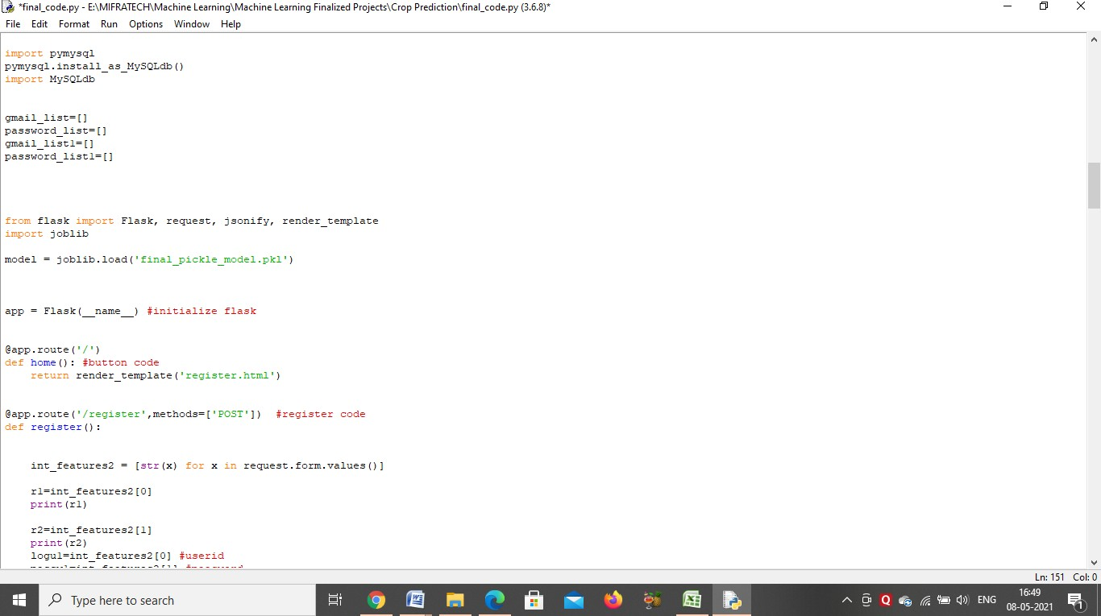

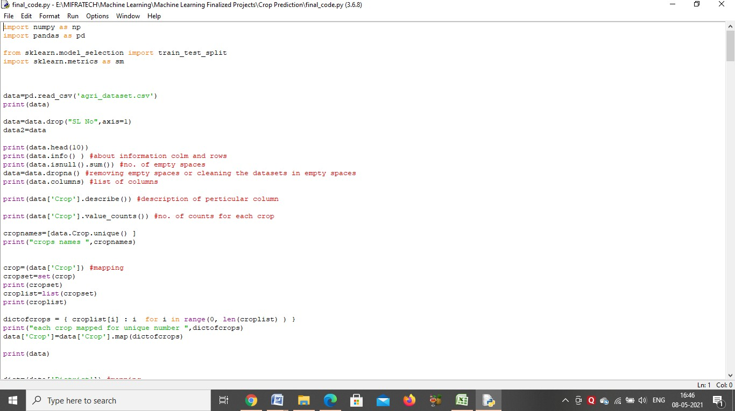
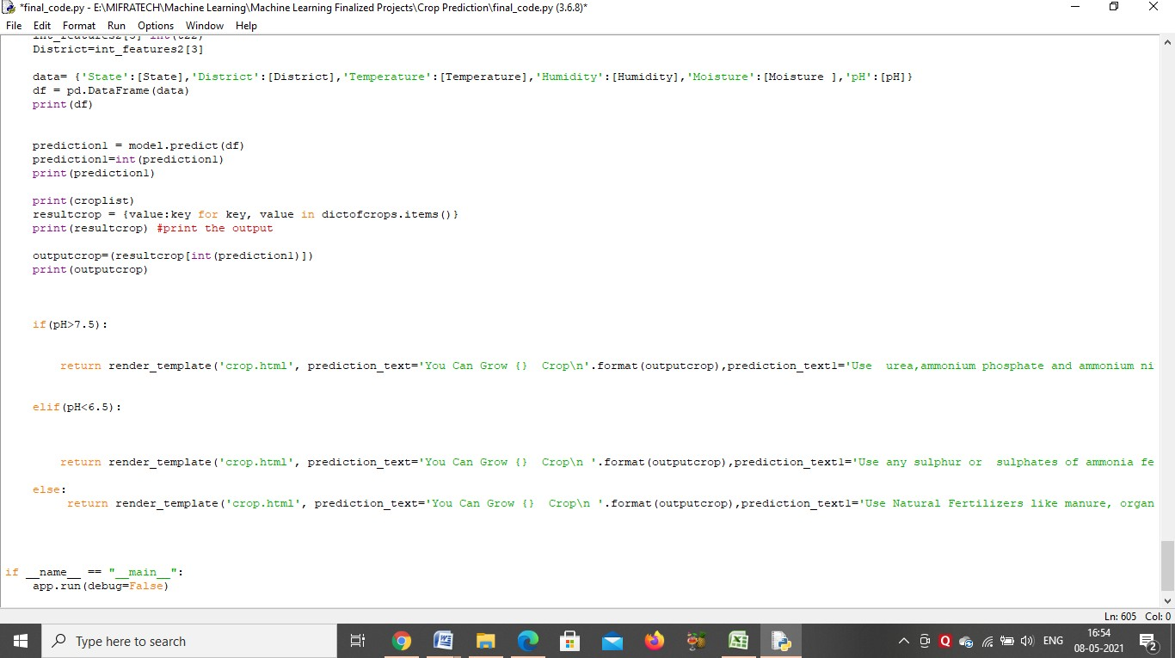

APPENDIX-B SCREENSHOTS
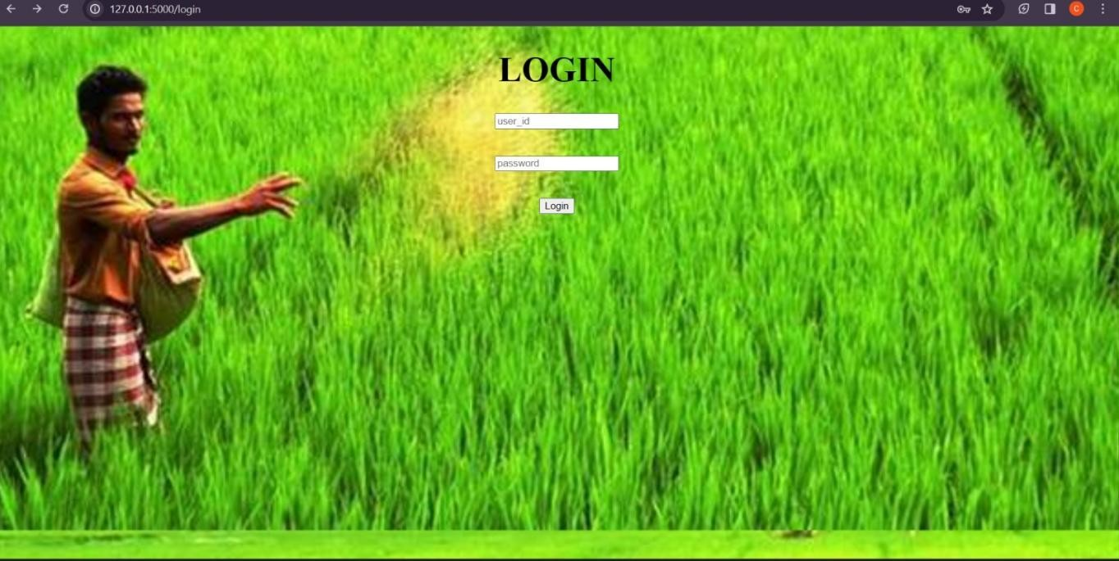



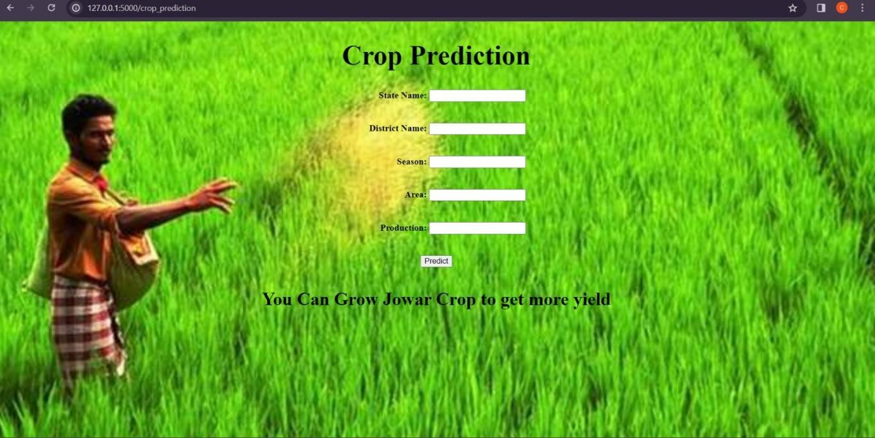

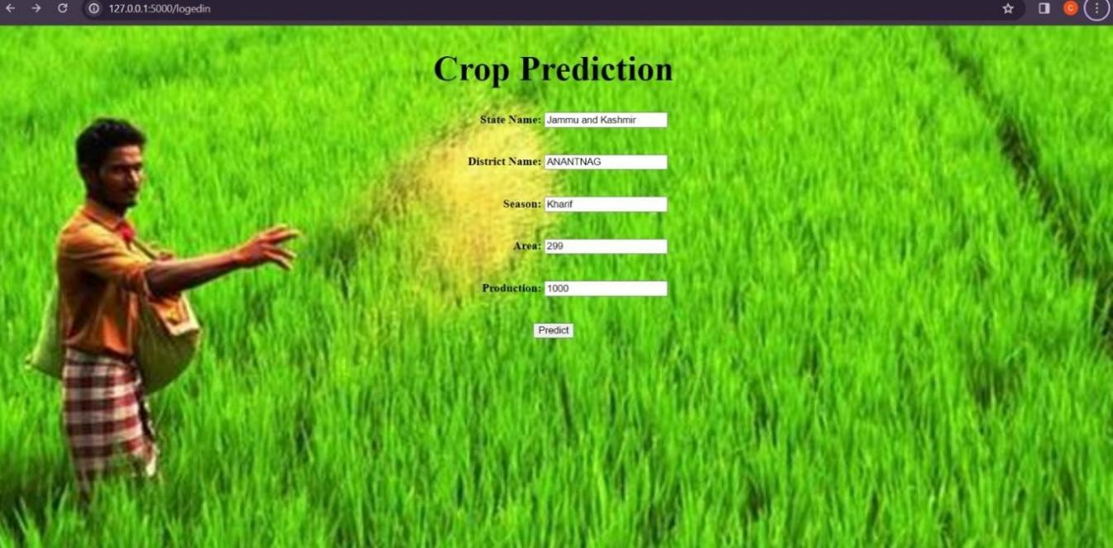
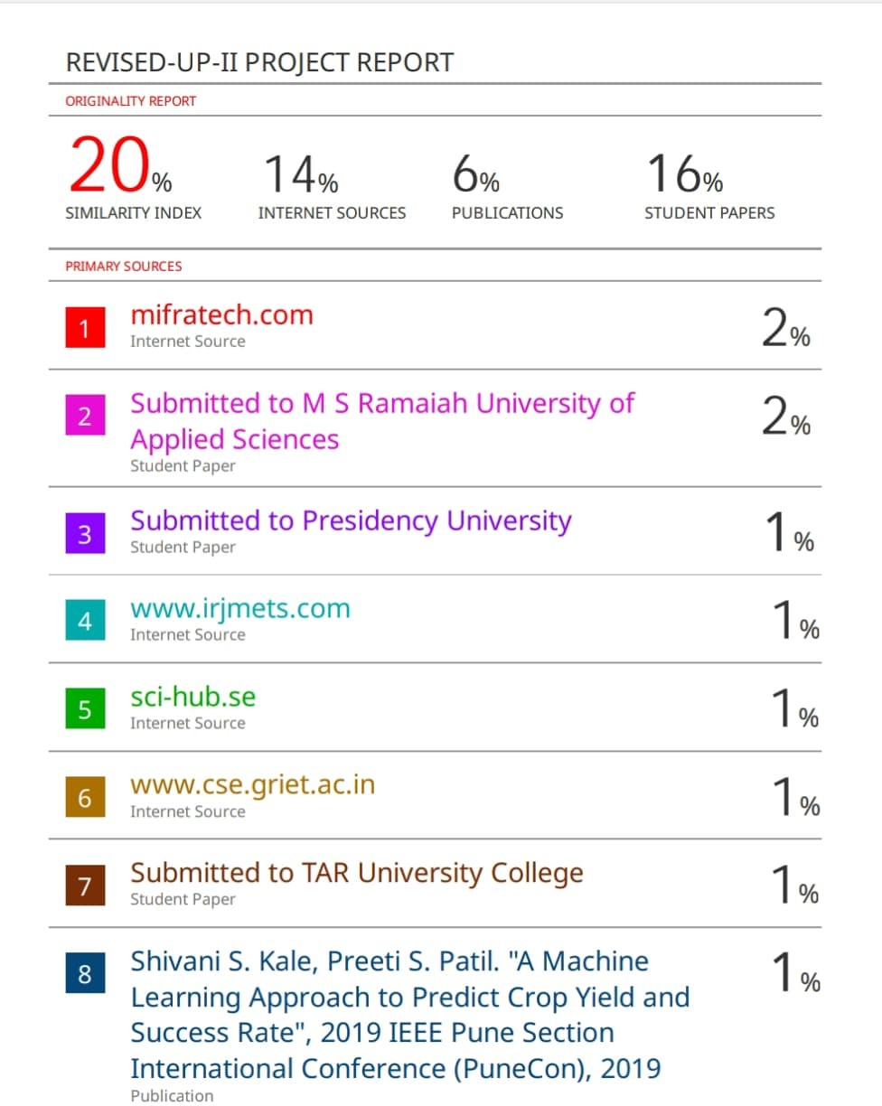



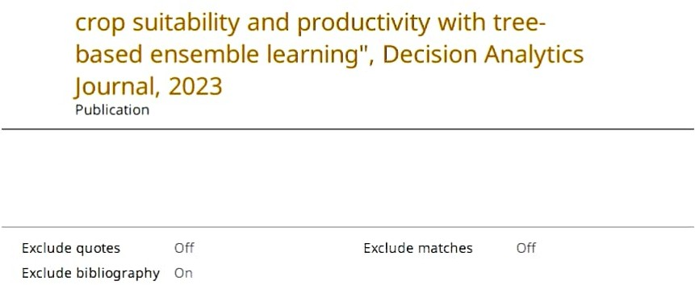


(A Monthly, Peer Reviewed, Referred, Scholarly Indexed, Open Access Journal Since 2013)

Impact Factor 8.379

Rishitha Chinmayi
Department of Computer Science and Engineering with a specialisation of Data Science, Presidency University, Bangalore, India

Published a paper entitled

" Cash Crop Loss Prediction Using Deep Learning Techniques"

in IJIRCCE, Volume 12, Issue 1, January 2024

(A Monthly, Peer Reviewed, Referred, Scholarly Indexed, Open Access Journal Since 2013)

Impact Factor 8.379

Harsha vardhan
Department of Computer Science and Engineering with a specialisation of Data Science, Presidency University, Bangalore, India

Published a paper entitled

" Cash Crop Loss Prediction Using Deep Learning Techniques"

in IJIRCCE, Volume 12, Issue 1, January 2024

(A Monthly, Peer Reviewed, Referred, Scholarly Indexed, Open Access Journal Since 2013)

Impact Factor 8.379

Jaswanth kumar
Department of Computer Science and Engineering with a specialisation of Data Science, Presidency University, Bangalore, India

Published a paper entitled

" Cash Crop Loss Prediction Using Deep Learning Techniques"

in IJIRCCE, Volume 12, Issue 1, January 2024

(A Monthly, Peer Reviewed, Referred, Scholarly Indexed, Open Access Journal Since 2013)

Impact Factor 8.379

Reddy Kiran
Department of Computer Science and Engineering with a specialisation of Data Science, Presidency University, Bangalore, India

Published a paper entitled

" Cash Crop Loss Prediction Using Deep Learning Techniques"

in IJIRCCE, Volume 12, Issue 1, January 2024

(A Monthly, Peer Reviewed, Referred, Scholarly Indexed, Open Access Journal Since 2013)

Impact Factor 8.379

Teja vamsi
Department of Computer Science and Engineering with a specialisation of Data Science, Presidency University, Bangalore, India

Published a paper entitled

" Cash Crop Loss Prediction Using Deep Learning Techniques"

in IJIRCCE, Volume 12, Issue 1, January 2024



